CHEMICAL KINETICS & CHEMICAL EQUILIBRIUM

CHEMICAL KINETICS

The branch of physical chemistry that deals with the rate of reactions is called chemical kinetics. The study of chemical kinetics includes:
- The rate of a reaction and rate laws,
- The factors as temperature, pressure, concentration and catalyst that influence the rate of a reaction;
- The mechanism or the sequence of steps by which a reaction occurs.

Reaction rate
The rate of a reaction tells as to what speed the reaction occurs. For example,
A → B
Reactant Product
The rate of a reaction is defined as the change in concentration of any of reactant or product per unit time.

Rate of reaction = rate of disappearance of A
= rate of appearance of B

rate = − 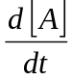 = + 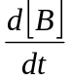 ;
where [ ] represents the concentration in moles per litre.

Rate Laws
An expression, which shows how the reaction rate is related to concentrations is called the rate law or rate equation.
2A + 3B → Products
rate = K [A]² [B]³, K = rate constant
Example-
- 2NO₂ → 2NO + O₂, rate = K [NO₂]² ;
- H₂ + I₂ → 2HI, rate = K [H₂] [I₂] ;

Order of a Reaction
The order of a reaction is defined as the sum of the powers of concentrations in the rate law.
rate = K [A]^{m} [B]^{n}
order of such a reaction is (m+n)
Example-
Rate law Reaction order
rate = K [N₂O₅] 1
rate = K [H₂] [I₂] 1+1=2
rate = K [H₂] [NO]² 1+2=3
rate = K [CHCl₃] [CI₂]^{½} 1+½=1½

Reactions may be classified according to order.
If m + n = 1, it is 1st order reaction
m + n = 2, it is 2nd order reaction
m + n = 3, it is 3rd order reaction

CHEMICAL EQUILIBRIUM
Chemical equilibrium may be defined as the state of a reversible reaction when the two opposing reactions occur at the same rate and the concentrations of reactants and products do not change with time.

Let us consider the reaction,
A + B  C + D
A + B → C + D (forward reaction)
A + B ← C + D (reverse reaction)
For example,
PCl₅ (s)  PCl₃ (s) + Cl₂ (g)
CaCO₃ (s)  CaO (s) + CO₂ (g)
H₂ (g) + I₂ (g)  2HI (g)

Characteristics of chemical equilibrium:
- Constancy of concentrations,
- Equilibrium can be initiated from either side,
- Equilibrium can not be attained in an open vessel,
- A catalyst can not change the equilibrium point,
- Value of equilibrium constant does not depend upon the initial concentration of reactants,
- At equilibrium change in Gibb’s free energy i.e. ΔG = 0
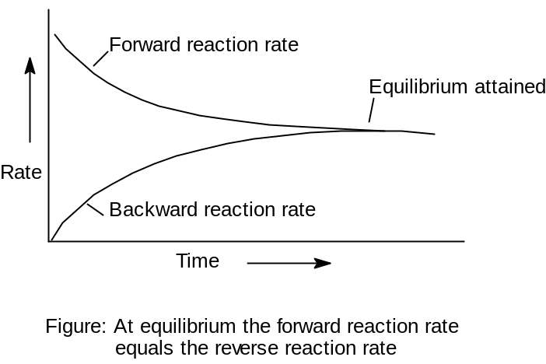

Equilibrium Constant: Equilibrium Law
For a general reaction
A + B  C + D
Rate of forward reaction [A] [B] = K₁ [A] [B]
Rate of reverse reaction [C] [D] = K₂ [C] [D]
At equilibrium,
K₁ [A] [B] = K₂ [C] [D]

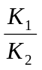 = 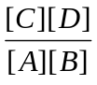
The ratio is called equilibrium constant, K_{c.}
K_{c} = = 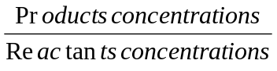
This is known as the equilibrium constant expression or equilibrium law.

